Project Report II

Bespectacled Builders

Elena Corpus, Lucas Iverson

CSCI 363 Fall

17 November 2019

Interface Drawing

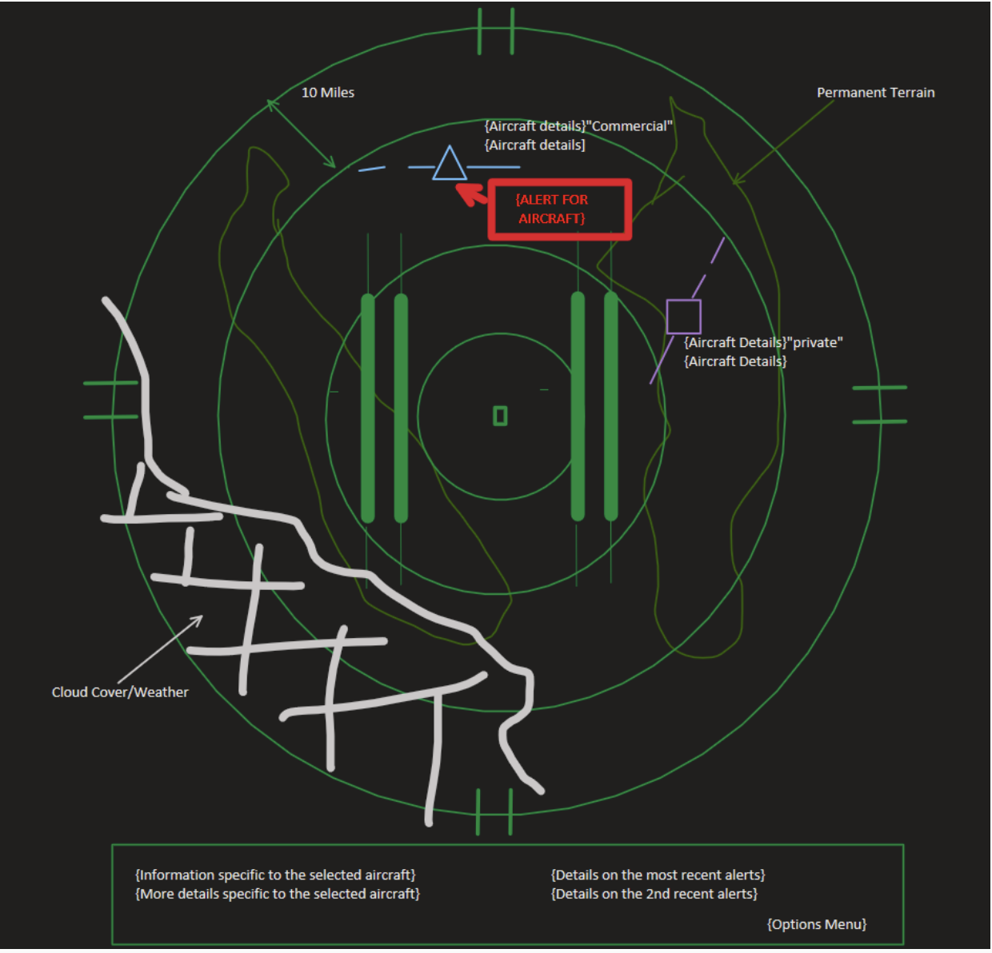

Class Diagram

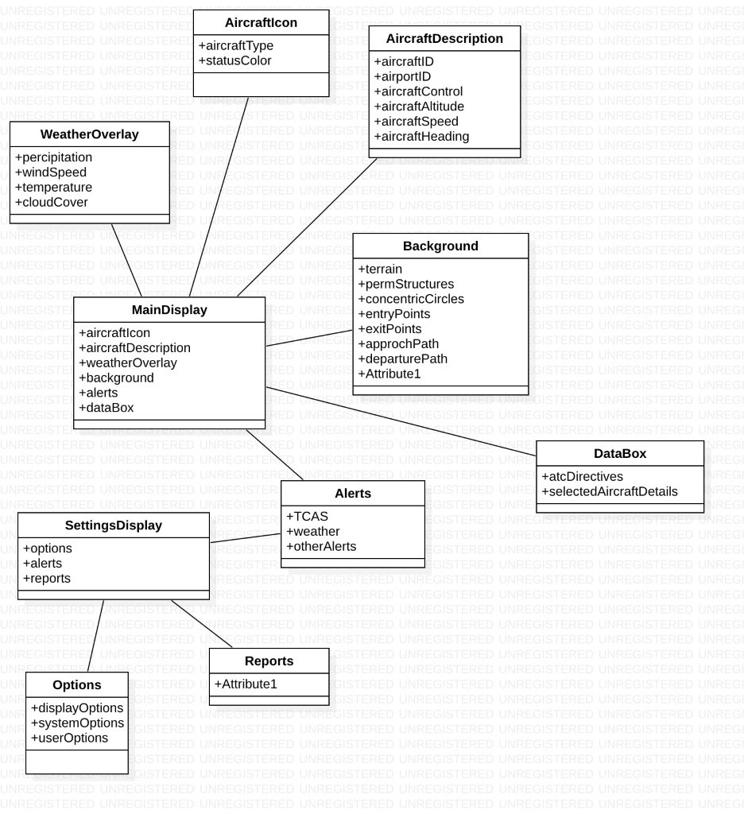

Use Case Descriptions and Activity Diagrams 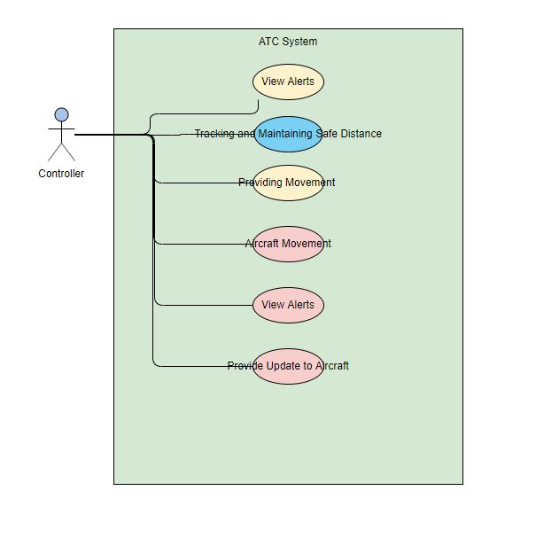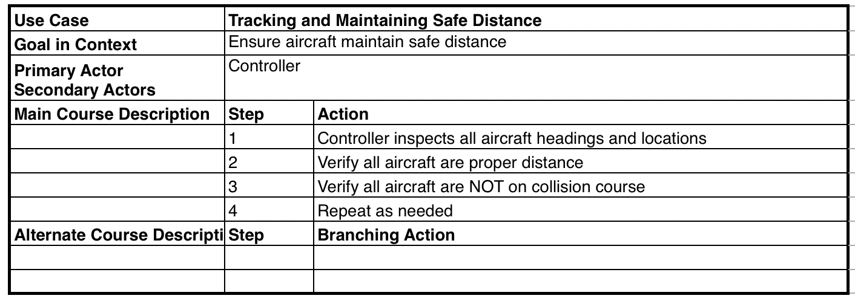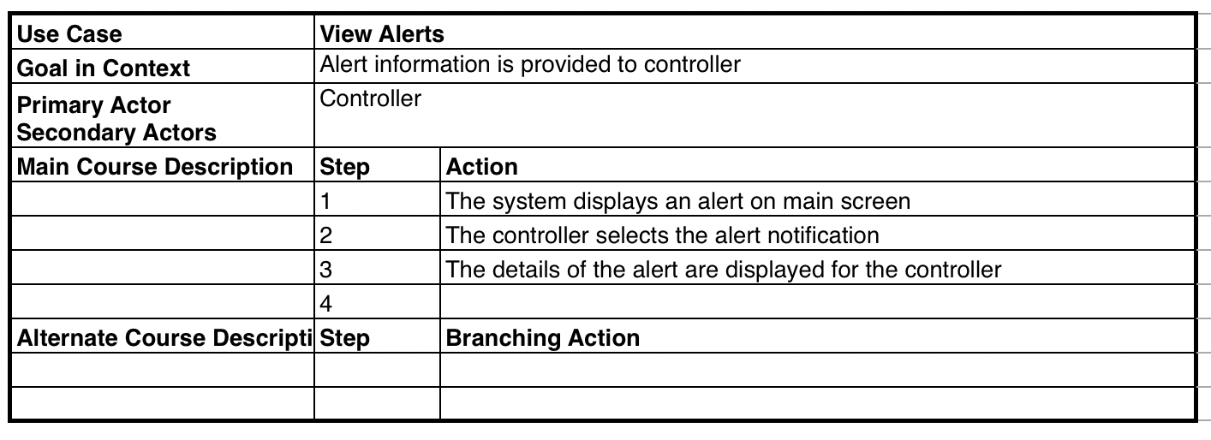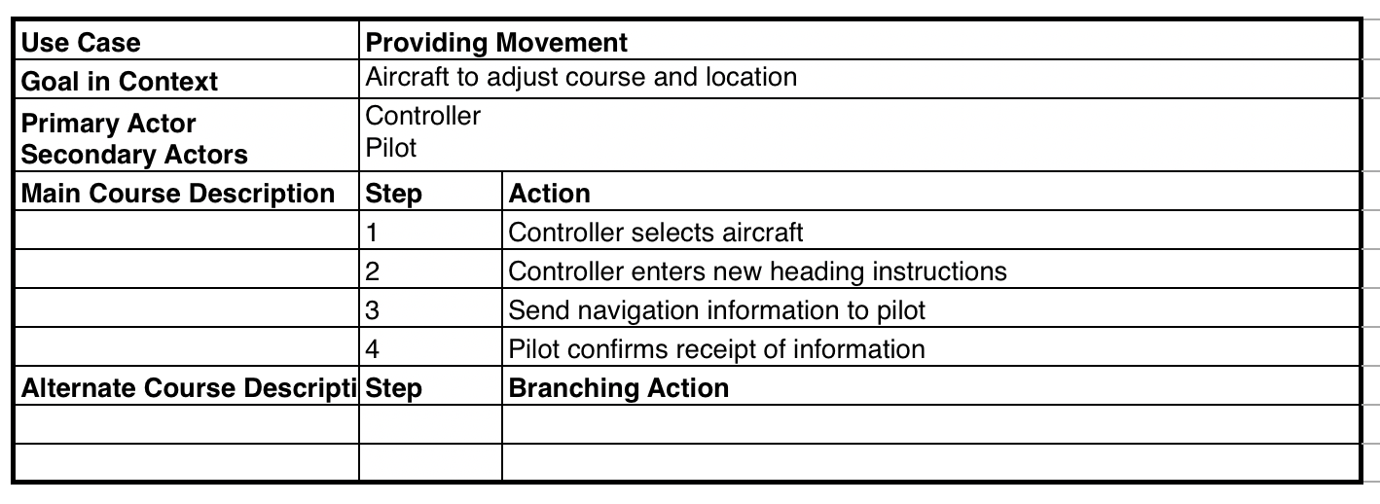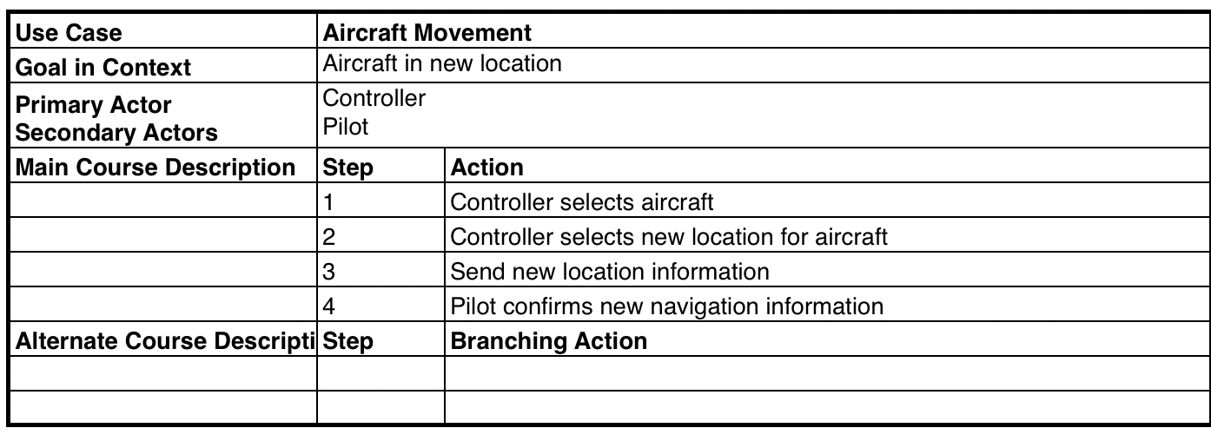

1. Statement of Issues encountered and their resolutions
   1. There is no significant issues that were encountered. We were able to work as a team to figure out what is needed to be done.
2. Statement of what is to be accomplished by the next reporting period (coding, presentation, and submission)
   1. Coding: Our code should be completed by the next reporting period.
   2. Presentation: Our date of presentation is December 4th, thus to insure that we are on-time and ready to present our User Interface Design, we are planning to finish on December 2nd so we are able to fully go through to ensure no bugs, and to fix all potential errors before we present.
   3. Submission: The date of last submission is on the 11th of December; however, we are presenting on the 4th. This just means that we are going to have to submit our design a week prior to the actual due date.